Mapp Empower Magento Plugin Installation Guide

  - Magento Version 2.3.2
  - Last Updated: September 11, 2019

Table of Contents
About the Guide 3
Release History 3
Intended Audience 3
Administration Management 4
Prerequisite check 4
Backing up Magento 4
Installing the Mapp Empower Plugin 5
Clearing the Cache 6
Uninstalling the Plug-in from Magento 7

About the Guide
This installation guide explains the installation procedure and required configuration settings for the Mapp Empower Magento plugin. The steps are provided to configure Mapp Empower Magento plugin after successful installation.

Release History

Release Version | Release Date | Sections Affected | Description
1.0 | June, 2015 | All | Mapp Empower Magento plugin Installation Guide for Magento Enterprise Edition.
1.x | Nov, 2016 | All | Mapp Empower Magento plugin Installation Guide for Magento Enterprise Edition.
2.1.x | Aug, 2017 | All | Mapp Empower Magento plugin Installation Guide for Magento Enterprise Edition.
2.2.x | Oct, 2018 | All | Mapp Empower Magento plugin Installation Guide for Magento Commerce Edition.
2.3.x | Sep, 2019 | All | Mapp Empower Magento plugin Installation Guide for Magento Commerce Edition.

Intended Audience
The installation guide is primarily intended for administrators responsible for integration of the Mapp Empower Magento plugin with their Magento installation.

Administration Management
The chapter provides configuration details of Mapp Empower Magento plugin on Magento.
Administration management includes the following administrative tasks:
- Backing up Magento
- Installing the Mapp Empower Plugin
- Clearing the Cache

Prerequisite check
To check your system for prerequisites, enter the following commands

- Check PHP SSH2 plugin installed on server or not by using this command “php -m | grep ssh2 “if it is installed on server then result of will be “ssh2” as shown in image.
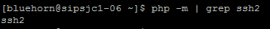
- Check Lftp package is installed on server by using lftp command as shown in image
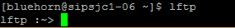
- Open /etc/lftp.conf file and add “set sftp:auto-confirm yes”
- To connect plugin to Mapp Empower, it is necessary to whitelist the IP address of the Magento installation server. When logged into Empower, go to Administration -> Configure Settings -> API Settings to add the IP to the whitelist.
- Check the write permission of FTP/SFTP server. To check write permission logged into Magento admin panel got to Mapp Empower-> Empower Configuration->FTP Configuration by using this FTP/SFTP details try to upload file from FileZilla to location given in settings
- Confirm from your hosting partner that, are we able to write file on other FTP/SFTP server by command line or not as well as confirm from Mapp Empower team that, are they allow our server to write file on FTP/SFTP server.
- Make sure that read-write permissions are correctly set for operative user as per Magento installation guide.
Reference: https://devdocs.magento.com/guides/v2.3/install-gde/prereq/file-sys-perms-over.html?itm_source=devdocs&itm_medium=quick_search&itm_campaign=federated_search&itm_term=permi
https://devdocs.magento.com/guides/v2.3/install-gde/prereq/file-system-perms.html

Backing up Magento
It is recommended to back up your Magento files and database before installing the plugin.

Installing the Mapp Empower Plugin
- Unzip/Untar the Mapp Empower plugin file into the Magento root installation directory.
After the file is extracted, the Mapp Empower directory will be created within the code directory, as shown below.
Note:
It is recommended to test the plugin on the development environment in order to detect any conflicts with the existing plugins.
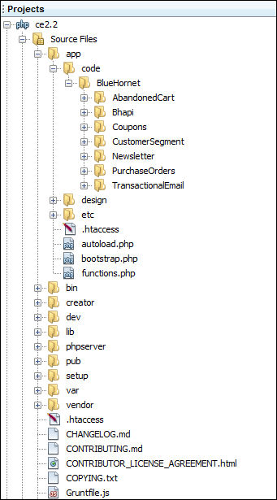
After the successful installation you have to run the command on Magento2 root directory-“php bin/magento setup:upgrade”
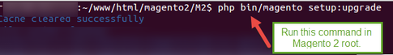

Clearing the Cache
After installation of the Mapp Empower plugin, clear the Magento cache.
Note:
The user is required to logout and re-login as Admin, or a 404 error result is displayed.
To clear the Magento cache:
- On the System menu, select the Cache Management option.
The Cache Storage Management page opens.
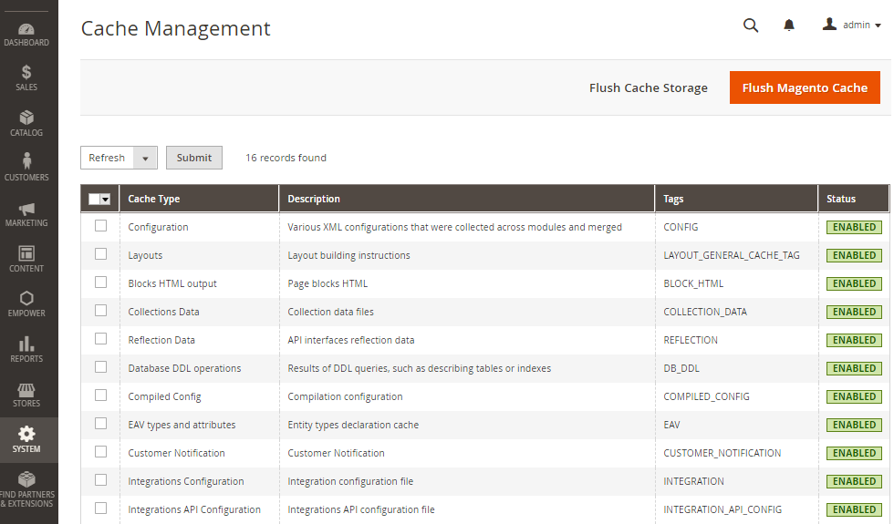
- Click the Flush Cache Storage button.
- In the Cache Storage Management list, click the Select All button.
- In the Actions list, select Refresh, and then click Submit.
The cache is cleared.

Uninstalling the Plug-in from Magento
Instead of uninstalling a module, you can disable and enable modules as shown in image
Disabling Modules :
Login to Magento server and navigate to magento root directory . Then navigate to bin direcotry and run this command.
[root@BH-wave bin]# php magento module:disable BlueHornet_AbandonedCart BlueHornet_Newsletter BlueHornet_Bhapi BlueHornet_Coupons BlueHornet_CustomerSegment BlueHornet_PurchaseOrders BlueHornet_Transactionalemail
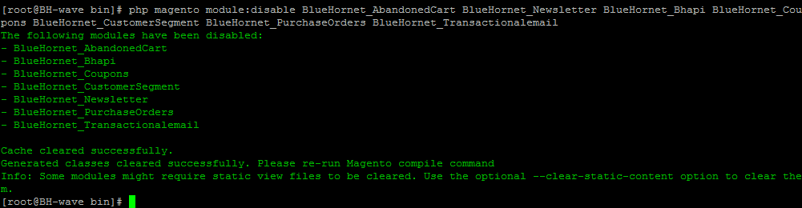

Enabling Modules :
Run below command in bin direcotry as shown in image
[root@BH-wave bin]# php magento module:enable BlueHornet_AbandonedCart BlueHornet_Newsletter BlueHornet_Bhapi BlueHornet_Coupons BlueHornet_CustomerSegment BlueHornet_PurchaseOrders BlueHornet_Transactionalemail

